**Red Team: Summary of Operations**

**Table of Contents**

* Exposed Services
* Critical Vulnerabilities
* Exploitation
* References

**Exposed Services**

Nmap scan results for each machine reveal the below services and OS details:

$ nmap -sV 192.168.1.*

Target 1 IP determined to be 192.168.1.110.

This scan identifies the services below as potential points of entry:

* Target 1
  + Port 22 – SSH access
  + Port 80 – HTTP access
  + Port 111 – RPC (Remote server access)
  + Ports 139 & 445 – NetBIOS (LAN access)

**Critical Vulnerabilities**

The following vulnerabilities were identified on each target:

* Target 1
  + Lack of updated software
    - The version of OpenSSH found on the target is vulnerable to numerous exploits including Username Enumeration (CVE-2018-15473)1
    - Apache server is running older version of the software vulnerable to significant exploits including2:
      * CVE-2019-0217: Access control bypass, allowing for alternate username authentication and overriding access controls
      * CVE-2017-9788: Memory pool leak, potentially exposing critical data
      * CVE-2017-3167: Authentication bypass
    - Wordpress server was also running out of date software vulnerable to detailed site enumeration via wpscan

* + Weak passwords
    - The user account “michael” had a very weak password capable of being exploited through manual brute force attack
    - The user account “steven” also had a fairly weak password that was subject to an automated brute force attack
  + Unsalted SQL credentials
    - The SQL credentials were found through an unencrypted file listed in /var/www/html/wp-config.php

* + Unsalted hashed passwords
    - When the SQL database was breached user passwords were found with an unsalted hash, leaving them subject to cracking through tools such as John

* + Privilege escalation
    - Once logged into the system through the ‘steven’ username, escalation to root privileges was performed via a python script

**Exploitation**

The Red Team was able to penetrate Target 1 and retrieve the following confidential data:

* Target 1
  + flag1.txt: b9bbcb33e11b80be759c43844862482d
    - **Exploit Used**
      * Utilizing wpscan, we enumerated the wordpress site containing the usernames for the computer, exposing “michael” and “steven”
      * Michael’s password was brute force guessed manually (password: michael) and allowed access to the file structure of the system
      * Flag1 was found among a file called “setup.html”



* + - * ssh michael@192.168.1.110
  + flag2.txt: fc3fd58dcdad9ab23faca6e9a36e581c
    - **Exploit Used**
      * Through directory traversal via the “michael” username, flag2 was found in the /var/www/html directory

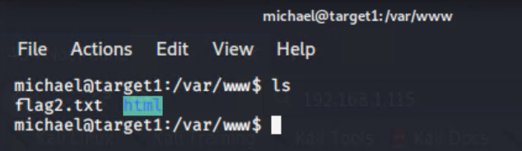

* + Flag3.txt: afc01ab56b50591e7dccf93122770cd2
    - **Exploit Used**
      * While doing directory traversal, the file “wp-config.php” listed unencrypted SQL credentials
      * Using these credentials, the database was accessed and a file containing the flag 3 information was found

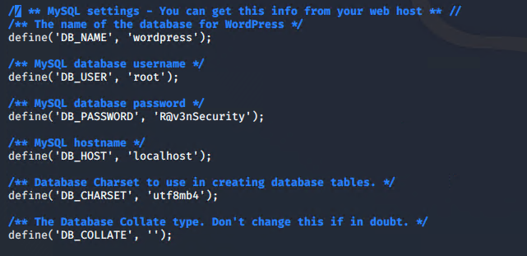

* + - * 1. $mysql -u root -p
        2. Mysql > show databases;
        3. Mysql > use wordpress;
        4. Mysql > show tables;
        5. Mysql > select * from wp_users;

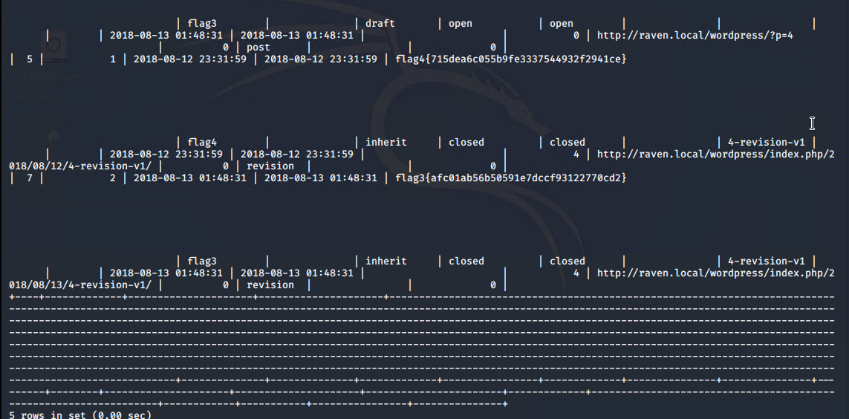

* + Flag4.txt: 715dea6c055b9fe3337544932f2941ce
    - **Exploit Used**
      * After finding flag 3, the user account ‘steven’ was logged into



* + - * Account permissions revealed the user could execute python scripts, including ones that escalated to the root user
        1. sudo python -c ‘import pty;pty.spawn(“/bin/bash”)

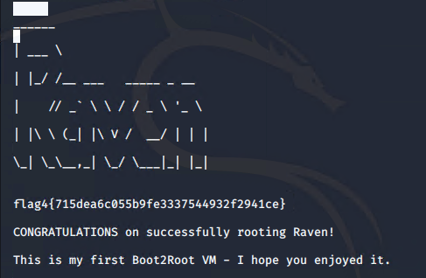

**References**

* + - * 1. <https://nvd.nist.gov/vuln/detail/CVE-2018-15473#vulnCurrentDescriptionTitle>
        2. <https://nvd.nist.gov/vuln/search/results?form_type=Basic&results_type=overview&query=apache+server&search_type=all&isCpeNameSearch=false>